A study on Recent VR Devices and its Applications

**ABSTRACT**

Virtual Reality (VR) has drawn much attention in the last few decades. By artificially stimulating our senses, make it possible for our bodies become trick into accepting another version of reality. There are lots of VR devices that shown. While VR technology holds enormous potential to change the future for a number of fields, it is applied in medicine operation training, architecture design, business, education, and manufacturing. This paper presents a definition, history, development limits, the latest VR devices and their characteristics, VR’s applications and development trend. 🡪 무슨 말인지 모르겠다. 다시 수정해 볼래. In this paper, we introduce the definition of VR and VR system; the development history of VR; the adverse effects to human health and hardware limits of VR; and introduced the latest VR devices and applications.

**INTRODUCTION**

Ⅰ. Virtual Reality

**1.1 Definition of VR**

VR is commonly used by the popular media to describe imaginary worlds that only exist in computers and people’s minds. 🡪 다시 수정해 볼래 Before the VR devices appeared, for a long time, The popular media use the word “VR” to describe imaginary worlds that only exist in computers and people’s minds. Jerald et al. [2] presented that VR is defined as “it is a computer-generated digital environment that can be experienced and interacted with as if that environment were real”. And asserted that VR is communication, they emphasized the importance of human factor that influence the interaction between the VR system and the users [2]. VR uses computer or other devices, simulate and generate a virtual world that be available to users interact with, and get immersive experience.

immersion, real-time interactivity, and imagination 🡪 각 3개에 대해 설명하는 게 필요함

VR has 3 main characteristics: immersion, real-time interactivity, and imagination. **Immersion** is the core characteristic, which is the objective degree to which a VR system and application projects stimuli onto the sensory receptors of users in a way that is extensive, matching, surrounding, vivid, interactive, and plot informing[20], Anyone who experiencing it can get the real sense of seeing, hearing, touching and smelling just like in the real world; **real-time interactivity** is the basic requirement, as users interact with the environment in the real world, the immersion feeling will be broke if the interaction is in an unnatural way or cost a latency time; **Imagination** is the ideal purpose of VR, which is also means creativity, the very beginning of VR world, VR can be made just like the reality or nonexistent things, through the experiences users get new Knowledge or Experience, they can establish new cognition.

**1.1.1 The VR System**

VR system has four main categories as follows Desktop VR system, Augmented VR system, Immersive VR system (consists of HMD-VR, Projection display based-VR, telepresence system VR), and Distributed VR (DVR)[10]. In this paper, we describe the most common HMD-VR Immersive VR system, as be show in Fig.1, it is consider of VR [goggles](javascript:void(0);), host system, tracking system, and control system [11], the VR [goggles](javascript:void(0);) generally has the display integrated screen or smartphone screen inside of it also has earphone to get the sound, it can track the head movements, the control system is the interaction part that users use their hands Grabbing or touching the objects in the virtual r[eality](javascript:void(0);) world; host system part get and process the information get from the tracking system and the control system and react to them.

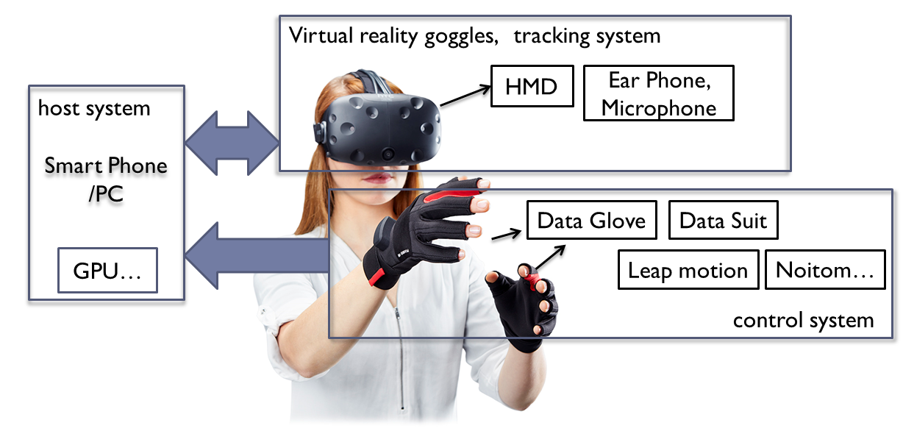

Fig.1 Constitution of VR System

According to the characteristics of VR, the VR System can be evaluated by 3 indexes which are P (Presence), I (Interaction), A (Autonomy). Presence is the degree of user’s immersion which is depended on the display effect and the tracking system in the HMD; Interaction is the degree that whether the control tools such as data gloves can provide a natural way or not; Autonomy is the degree that users’ determination what they will do next. Obviously, when PIA all get their max value the property of VR system will be the best effect [7]. As Fig.2 shown, the bigger P, I, A values are the better VR system effect will be.

PIA에 대해 조금 더 자세한 설명이 필요함

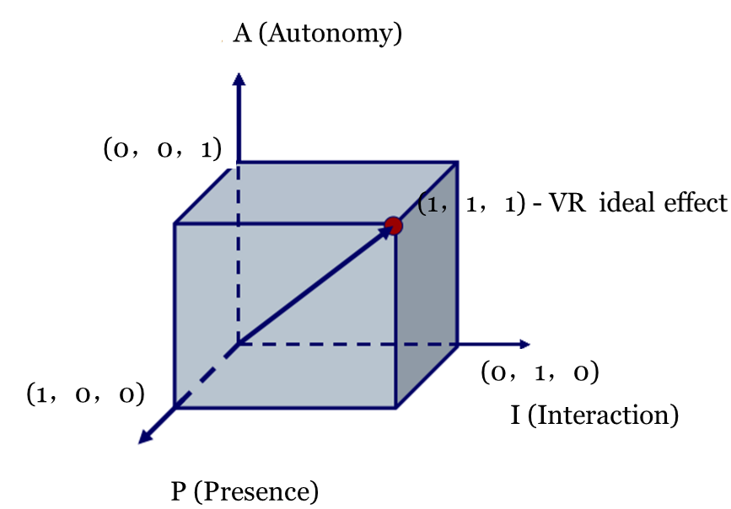

Fig.2. VR system marking criterion

Ⅱ. Development of VR and Its’ Limits

**2.2 History of VR**

VR has already shown for 80 years. In **20 century 30s~70s - the exploration stage**, in 1935, American science fiction writer [Stanley G.Weinbaum](http://en.wikipedia.org/wiki/Stanley_G._Weinbaum) presented the concept of virtual reality in his short story [3].Sutherland I.E. the creator of one of the world’s first VR systems, and Dr. Frederick P. Brooks, Jr., inspired by Ivan Sutherland’s vision of the Ultimate Display **[4],** established a new research program in interactive graphics at the University of North Carolina at Chapel Hill, with the initial focus being on molecular graphics and in 1967, developed the first VR device HMD (head mounted display) and he stated:” The screen is a window through which one sees a virtual world. The challenge is to make that world look real, act real, sound real, feel real.” **During 80s - VR technology systematize from laboratory to practical stage**. In 1985, Scott Fisher, now at NASA Ames, along with other NASA researchers developed the first commercially viable, stereoscopic head-tracked HMD with a wide field of view, called the Virtual Visual Environment Display (VIVED). **Since 90s to now - the high speed development stage**. VR exploded in this period with various companies (Sega, Disney, and General Motors, as well as numerous universities and the military etc.) focusing mostly on the market and entertainment (movies, books, and is also active in journals, conferences).

**2.2 Limits and Adverse effects of VR**

Since 2000s, there are plenty of original stage products published, however because of the limits of VR technology, it is not so popularize yet. Among the reasons for VR not popularize is its hardware limits which can make users fell vertiginous after a long time using, The VR developers must rise to the challenges on hardware limits and adverse effects on human health.

* + 1. **Hardware limits:**
* Latency: System delay is the sum of delays from tracking, application, rendering, display, and synchronization among components. Low-accuracy head trackers result in seeing the world from an incorrect viewpoint; Low Refresh frame rate cause latency, the latency detracts from the sense of presence in HMDs, the VR display devices need to reach at least 120HZ. On the other side, low resolution can cause visually strong grainy, theoretically resolutions need to be higher than 4K.

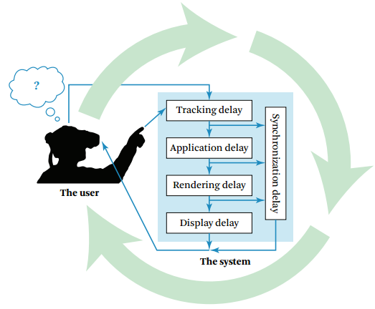

Fig.3. End-to-end system delay comes from the delay of the individual system components and from the synchronization of those components. (Adapted from Jerald [2009])[2]

* Headset Fit: the degree of comfortable users feel, among this is the viewing angle, if visual range is bigger than the screen it’s easy to affect the viewing experience and immersion through eye movement.
* Portability: Mainly refer to the weight and battery life, heavy equipment, after long periods of oppression can make user discomfort and add fatigue, for the wired devices, it’s difficult for the user to move around freely; for the VR-all-in-one devices, short battery life and weight are the key limiting factors.
* Interaction way: Some unnatural ways like touch the screen; magnet button; Joypad adaptor, single Bluetooth; Sensor Devices: The force sensation, haptic sensor cannot afford an accuracy control by the users. It is important to find a more fitness way that people can easy interact with as much as possible like the real world.

~~In the years to come, how much VR can develop to some extent depending on relevant hardware technology development, at that rate, the more forming and good price VR products will be Flow to the market and become the mainstream.~~

🡪 다시 작성해 줄래

2.2.2 **Adverse effects of VR**

Because of the limits, the existing VR system and applications can cause adverse health effects, such as nausea, eye strain, headache, vertigo, physical injury, and transmitted disease.

* Vertigo: The reason that make the user feel vertigo after a long time use is because of Accommodation-Vergence Conflict(AVC). It is occurs due to the relationship between accommodation and vergence not being consistent with what occurs in the real world, Overriding the physiologically coupled oculomotor processes of vergence and accommodation can result in eye fatigue and discomfort [19]. In addition the latency of the VR system can also the main reason for vertigo.

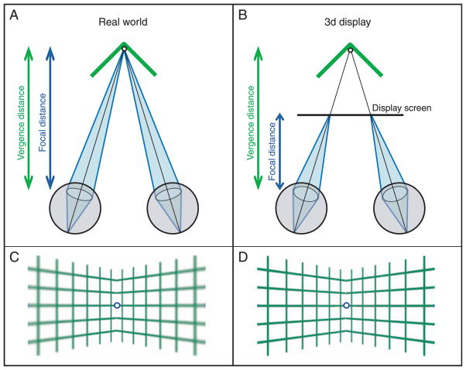

Fig.4 the vergence distance and focal distance are focus at one point(a), in VR can not focus at one point(b) [18]

* Physical Fatigue: Because many of the VR devices are not portable, and interaction with arms, users may feel very tired after use a long time.

Ⅲ. VR devices and its applications

**3.1 VR devices**

The composition of the VR devices can be classified as display device; input/feedback(interaction) device; and the filming equipment. Display devices can also be divided into 3 kinds; PC+VR; Mobile +VR; and VR-all-in-one. PC+VR devices have high quality and more expensive than others. Mobile +VR devices are easy convenient for beginners. VR-all-in-one device is disputed for its heavy weight, and short battery life, The Fig.2 shows some well-known devices in each kind of VR devices, and Fig.3 shows the representative VR devices.

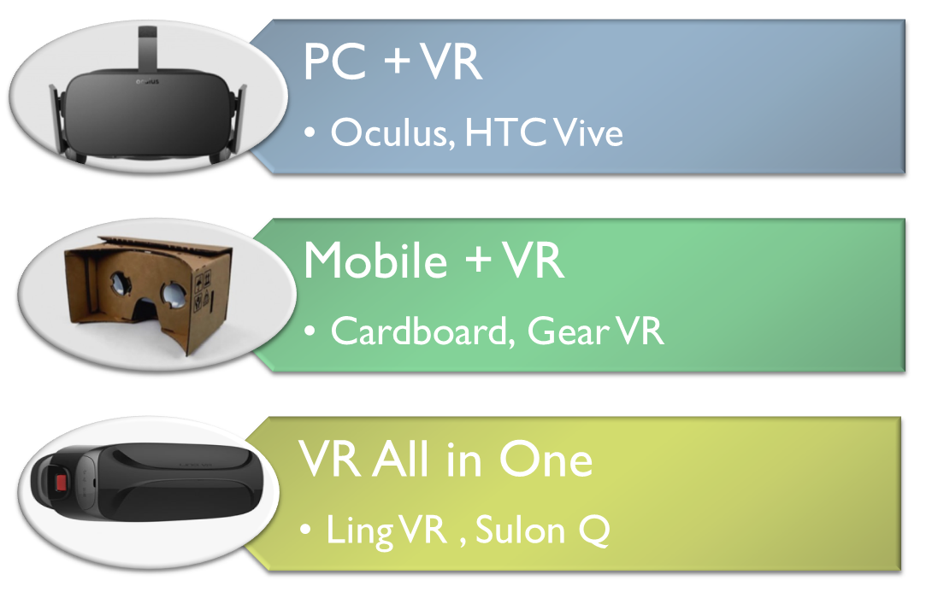

Fig.2 Category of VR devices

Fig.3 Representative recent VR devices

**Oculus Rift –** Going public on March 25 by Facebook, 2016, it is a PC-VR device that has configured screen and sensing device, The headset device two OLED panels, each having a resolution of 1080×1200, the connecting PC must have a high configuration, and it also has controller devices- a pair of handheld units, each containing a joystick, buttons, and two triggers - one for grabbing and one for shooting or firing.

**Sony PlayStation VR** – Launches in October 2016 By Sony, it is also a PC-VR device that has an OLED, and the resolution of each eye is 960 × 1080 pixels[13], the controller is called PlayStation MOVE, it has A small loss of immersion sense and  comparatively cheap Compared to the others.

**HTC Vive Pre –**– Launchesat [Consumer Electronics Show](https://en.wikipedia.org/wiki/Consumer_Electronics_Show) 2016, HTC and Valve unveiled a near-final hardware revision of the device, known as HTC Vive Pre [15], the two display screen has a [refresh rate](https://en.wikipedia.org/wiki/Refresh_rate) of 90 [Hz](https://en.wikipedia.org/wiki/Hertz), and resolution of 1080x1200. It has many improvements compare to the previous. The controller is more convenience and looks lighter the front-facing camera called “Chaperone” [14], allows the software to identify any moving or static objects in a room.

**Samsung Gear VR –** A mobile-VR device that use Galaxy Note 4.

**Google Cardboard –** Google published Cardboard in 2014enable low-cost($2) VR using existing smart phones, and has a magnet button as the input device.

**FOVE VR –** The first eye tracking VR headset, add two infra-red cameras below the lens and not disturb users’ experience, It can aim the users’ eyes, tracking user’s viewpoint, This enables the graphics engine to adjust focus and allocate rendering resources accordingly look, laugh, and communication with character just like in the real world[16].

**Avegant Glyph –** has no traditional screen, what the user see is the projection on users’ eyes and for this reason it a 120Hz Refresh Rate and 45°view angle, the high Refresh Rate make it has no latency, the narrow view angle make user less immersion.

**Google DaydreamVR** - has been published at May, 2016 in Google I/O Conference, it optimized the algorithm, therefore it can [reduce](javascript:void(0);) [latency](javascript:void(0);) and vertiginous sensation effectively, it support various smart phones, and the Pixel phone develop by Google is the first one supported. The developers also further enriched software in the fields of watching movies, playing games, watching games. Fig.4 shows the Pixel phone (left) and Daydream View HMD(right)

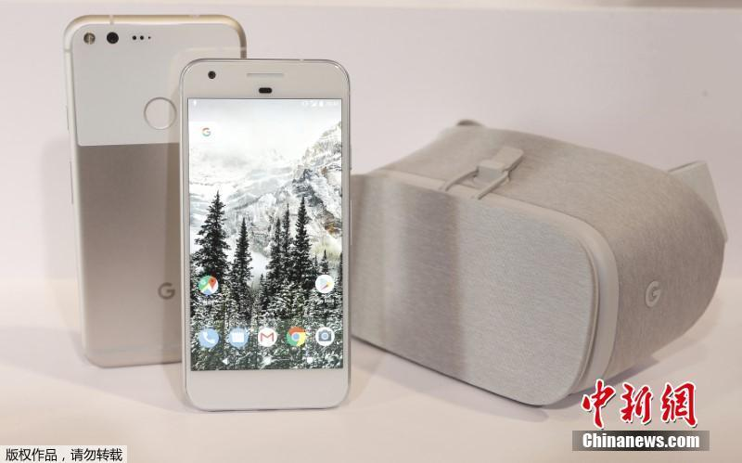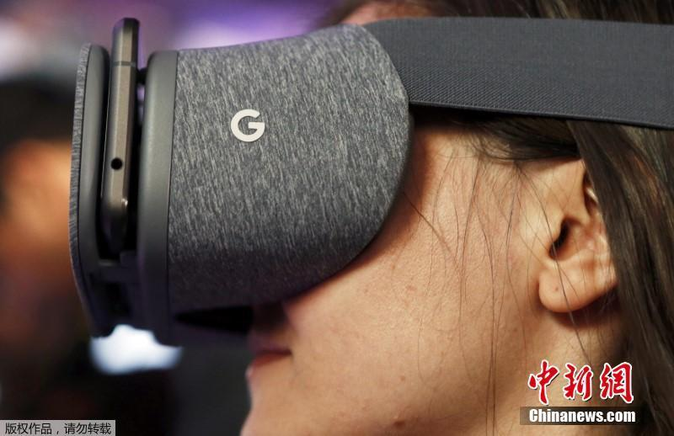

Fig. 4 Daydream View- Pixel phone (left) Google Daydream VR HMD(right)

**Pico Neo and DeepoonM2** - In China, the latest and the most popular VR-all-in-one devices are Pico Neo and DeepoonM2 for they are more portable than PC-HMDs. DeepoonM2 is integrated, however Pico Neo is split type. In the terms of weight, 350g(Pico Neo), 398g(DeepoonM2. Fig.5 shows the Pico Neo and its controller (left) and DeepoonM2 (right)

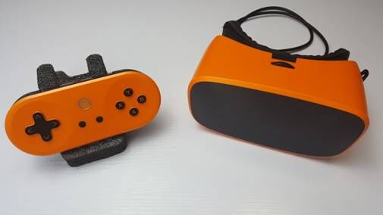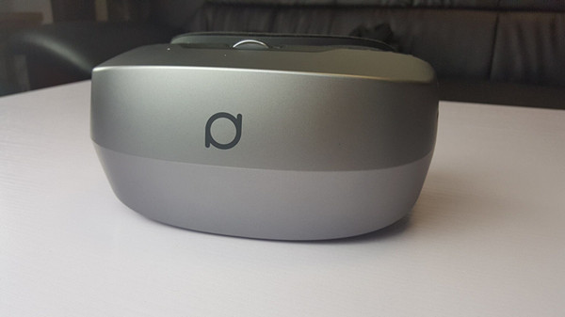

Fig.5. VR–all–in one devices - Pico Neo (left) and DeepoonM2 (right)

VR devices 아래 표 처럼 만들어요?

|  |  |  |  |  |
| --- | --- | --- | --- | --- |
| VR device | category | published | resolution |  |
| **Oculus Rift** | PC-VR | March 25, 2016 | two OLED panels each 1080×1200 | has controller devices- each containing a joystick, buttons, and two triggers - one for grabbing and one for shooting or firing |
| **Sony PlayStation VR** | PC-VR | Oct. 2016 | each eye is 960 × 1080 pixels | the controller is called PlayStation MOVE, it has A small loss of immersion sense and  comparatively cheap Compared to the others |
| **HTC Vive Pre** | PC-VR | 2016 | [refresh rate](https://en.wikipedia.org/wiki/Refresh_rate) of 90 [Hz](https://en.wikipedia.org/wiki/Hertz), and resolution of 1080x1200 | It has many improvements compare to the previous. The controller is more convenience and looks lighter the front-facing camera called “Chaperone” [14], allows the software to identify any moving or static objects in a room. |
| **Samsung Gear VR** | mobile-VR |  |  | use Galaxy Note 4 |
| **Google Cardboard** | mobile-VR | 2014 |  | low-cost($2) VR using existing smart phones, and has a magnet button as the input device |
| **FOVE VR** | PC-VR |  |  | The first eye tracking VR headset |
| **Avegant Glyph** |  |  |  | has no traditional screen  the high Refresh Rate make it has no latency, the narrow view angle make user less immersion |
| **Pico Neo and DeepoonM2** | VR-all-in-one | 2016 |  | 350g(Pico Neo), 398g(DeepoonM2 |
|  |  |  |  |  |

**3.2 Applications of VR**

As VR technology has enormous potentiality, but what is it made for? VR significant useful in fields such as data and architectural visualization, medical treatment, military, aerospace, business, product design and manufacturing, and as an enjoyable education or training tool that are professional utility applications. For entertainment, it is used in the fields of game, movie, and scene experience.

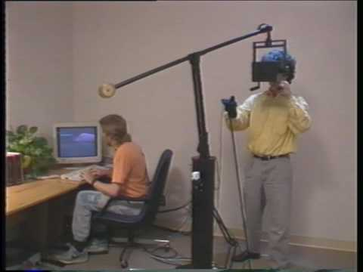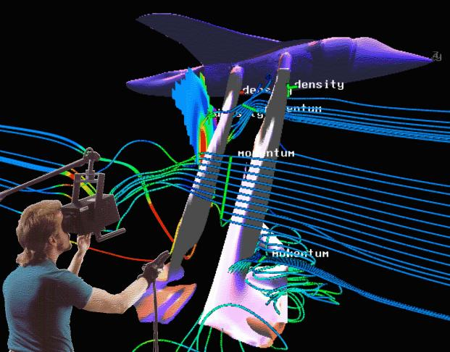

Fig.6 The Virtual Windtunnel (VWT) system

Psychologists and other medical professionals have been using VR to heighten traditional therapy methods and find effective solutions for treatments of PTSD (post-traumatic stress disorder), anxiety and social disorders. Doctors employ VR to train medical students in surgery, treat patients’ pains and even help paraplegics regain body functions. In business, a variety of industries are benefiting from VR. Carmakers create safer vehicles, architects are constructing stronger buildings and even travel agencies use it to simplify vacation planning. Fig.6 shows an application of  the [Virtual reality](http://www.nas.nasa.gov/Software/VWT/vr.html) interface technology to the visualization of the results of modern computational fluid dynamics simulations outside view(left), inside view(right) [9].

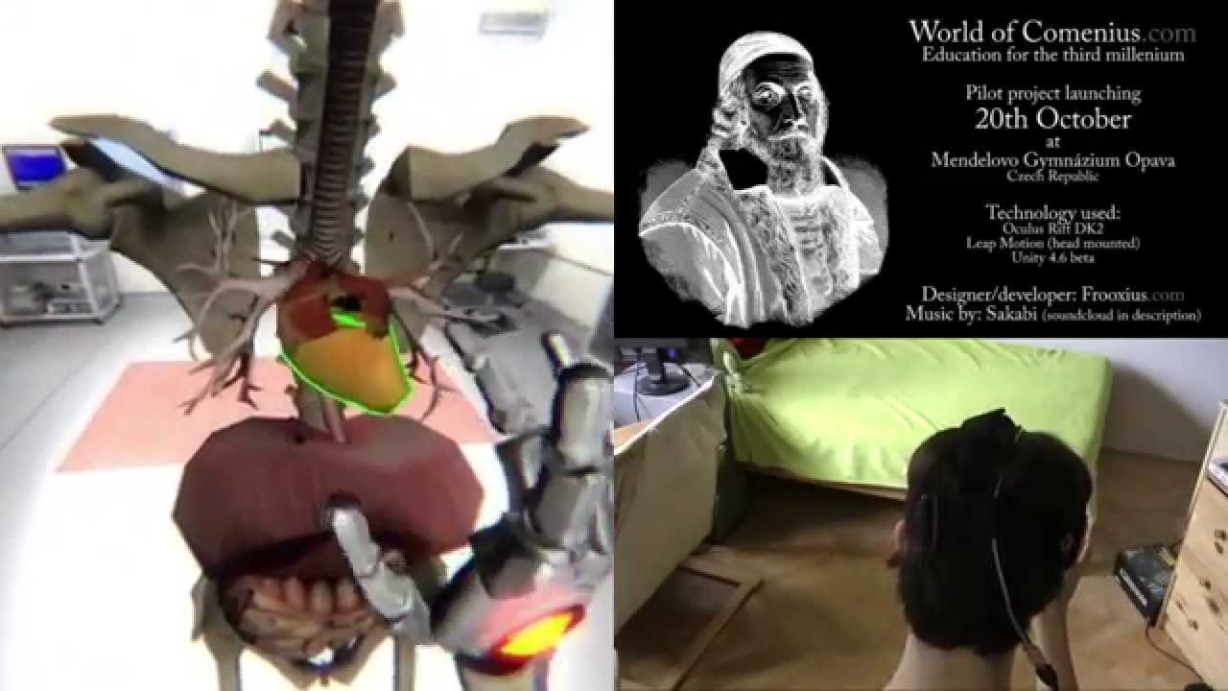

Fig.7. [**World of Comenius**](https://www.youtube.com/watch?v=-W18BylZk6o)

Fig.7 shows biology lesson at a school in the Czech Republic that employed a Leap Motion controller and specially adapted Oculus Rift DK2 headsets, stands as an exemplary model of innovative scientific learning.

The most remarkable characteristic of VR is the fidelity, immersive and real-time interaction using VR that is an effective way for practical and creative education, as the teaching method can be very flexible. As Confucius stated: ”I see and I forgot. I hear and I remember. I do and I understand.” we can hear with our ears; see with our eyes; but can’t do whatever we want, VR make it possible for us to understand the world we live in more simple and direct. Students can have a strong sense of presence being in and control the virtual world made though software, during interaction with the objects with the help of human Instinct capacity of cognitive and perceptual, through more intuitive way course, facilitate the students better memory and understanding the knowledge. In terms of school education, Professional skills training and scientific research, VR be used in [molecular](javascript:void(0);) [structure](javascript:void(0);) modeling, seismic exploration data processing, provide an intuitive visual graph, the natural sciences, humanities history, language, and physical, chemical fields etc. VR provide an immersive environment for students to experience, obtain knowledge more effectively easier to remember though video games, meanwhile, VR can save the cost of study. Fig.8 shows In Japan, students attend their first day of school in VR devices.

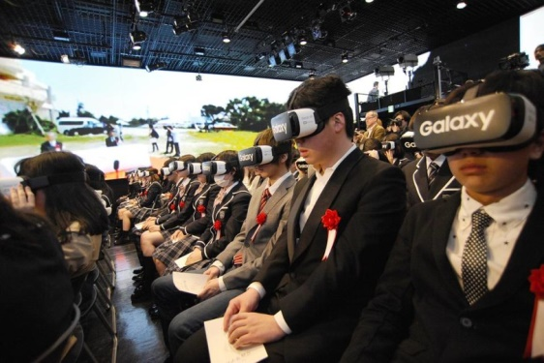

Fig.8 First Day of School in VR

[In](javascript:void(0);) [the](javascript:void(0);) [field](javascript:void(0);) [of](javascript:void(0);) entertainment applications like [game](javascript:void(0);), scene experience, VR bring people from the outside to the inside of the games. Fig.9 shows the latest application list that been download by the users.

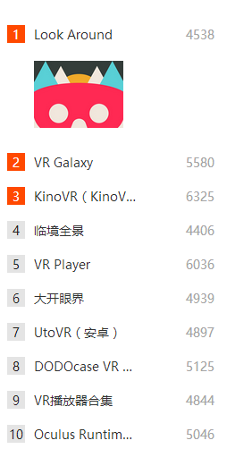

**Game Name(PC) download**

**App Name download**

Fig.9 The top of the most-downloaded applications list (left) and Game list (right) from the VR’s home site [5]

In the last few days, NBC used VR live telecast the American president election debate, people use Oculus Rift which owned by Facebook, HTC Vive, or SAMSUNG Gear VR, et al., mainstream VR devices, download AltspaceVR, he can watch it in a VR view, meanwhile he can set the image that though the role he can do some social activities. And such way was be token by NBC in the live telecast during the Rio Olympic 2016.

**3.3 The development trend of VR**

While VR was a non-starter back in the 90s, developers have been creating mind-blowing experiences that look set to revolutionize gaming and entertainment. Today, VR technology has been able to truly experience for consumers, but to rise to the level of industry, VR is still in the formative years, in terms of technology, products, content, specifications, are slightly immature, more importantly the interaction between users and VR is not nature , this can absolutely reduce immersion experiences.

With the development of VR technology application in education, entertainment, medical treatment, military, aerospace, business and product it is becoming more and more attractive. It is changing the way people perceive themselves, concepts of time and space, and the world, in the future, it will be more popularize, people directly experience it instead of just heard it or image it according to reports. 21 century will be the VR century.

CONCLUSION

VR is a realistic images that is generated with typically software and presented to the user. In this paper, we described the VR devices and its applications, also describing the limits of VR technology. We analyzed different of recent VR devices such as Oculus Rift, Sony PlayStation VR, HTC Vive Pre, Samsung Gear VR, Google Cardboard, FOVE VR, Avegant Glyph, Google DaydreamVR, Pico Neo, and DeepoonM2. Also this paper has provided a review of recent issue of VR.

**References**

[1] Joseph Isaac (2016). ["What is Virtual Reality?"](https://www.completegate.com/2016070154/blog/virtual-reality-explained#vrdef) completegate.com. Retrieved2 July 2016.

[2] Jason Jerald, NextGen Interactions (2016). " The VR Book: Human-Centered Design for Virtual Reality".

[3] [Stanley G.Weinbaum](http://en.wikipedia.org/wiki/Stanley_G._Weinbaum)(1935)  [Pygmalion's Spectacles](http://www.gutenberg.org/files/22893/22893-h/22893-h.htm)

<http://www.historyofinformation.com/expanded.php?id=4543>

[4] Sutherland, I. E. (1965). "The ultimate display". In The Congress of the International Federation of Information Processing (IFIP) (pp. 506–508). DOI: 10.1109/MC.2005.274. 9, 23, 30

[5] VR’s home. <http://www.vr.cn/>

[6] The Amazing Future of VR Medicine.

<https://www.youtube.com/watch?v=tcc0h_W2Sa4>

[7] Zeng Jianchao, Yu Zhihe, "VR system composition” Virtual Reality Technology  and  Applications".

[8] E-works (2015). "JT/VR Technology application in the development of commercial vehicle".

[9] S. Bryson, "The Virtual Wind Tunnel". (1993)

[10] Lu Juan, "The Classification  of  Virtual Reality System", Guide To Business 2011.4, TP391.9

[11] <https://www.douban.com/note/574937977/>

[12] <http://www.tibet.cn/news/china/1475649049728.shtml>

[13]  ["PlayStation VR Launches October 2016"](https://www.sony.com/en_us/SCA/company-news/press-releases/sony-computer-entertainment-america-inc/2016/playstationvr-launches-october-2016-available-glob.html). Sony. RetrievedMarch 15, 2016.

[14]  Alex Vlachos, Valve, ["Advanced VR Rendering, Alex Vlachos, Valve](http://alex.vlachos.com/graphics/Alex_Vlachos_Advanced_VR_Rendering_GDC2015.pdf)".

[15] Ars Technica. Retrieved 28 January 2016, ["HTC Vive Pre impressions: A great VR system has only gotten better"](http://arstechnica.com/gaming/2016/01/htc-vive-pre-impressions-a-great-vr-system-has-only-gotten-better/).

[16] [FOVE: The World's First Eye Tracking Virtual Reality Headset](https://www.kickstarter.com/projects/fove/fove-the-worlds-first-eye-tracking-virtual-reality?ref=card)

[17] “How Immersive is Enough?: A Foundation for a Meta-analysis of the Effect of Immersive Technology on Measured Presence”, James J. Cummings, Jeremy N. Bailenson and Mailyn J. Fidler.

[18] “VR is coming, but this big problem has not resolved yet,”2016. <http://wallstreetcn.com/node/234185>

[19] “Stereoscopy and the Human Visual System”, Banks, [Read](https://www.ncbi.nlm.nih.gov/pubmed/?term=Read%20JC%5BAuthor%5D&cauthor=true&cauthor_uid=23144596) et al. 2013

[20] Slater, M., & Wilbur, S. (1997). A framework for immersive virtual environments (FIVE) : Speculations on the role of presence in virtual environments. Presence : Teleoperators and Virtual Environments, 6(6), 603-616.